CSA1708-ARTIFICIAL INTELLIGENCE
LAB EXPERIMENTS
Program 28 : Prolog Program for Medical Diagnosis
Aim
To illustrate Prolog rules that match sample symptoms to condition labels.
Algorithm
1. Store sample symptoms as facts.
2. Define rules that match symptoms to conditions.
3. Query the diagnosis predicate for a person.
4. Prolog returns any condition whose rule matches.
Program
symptom(amy, fever).
symptom(amy, cough).
symptom(amy, body_ache).
symptom(ben, sneezing).
symptom(ben, itchy_eyes).
diagnosis(P, flu) :-
symptom(P, fever),
symptom(P, cough),
symptom(P, body_ache).
diagnosis(P, allergy) :-
symptom(P, sneezing),
symptom(P, itchy_eyes).
Sample Input
?- diagnosis(amy, Disease).
?- diagnosis(ben, Disease).
Program Execution
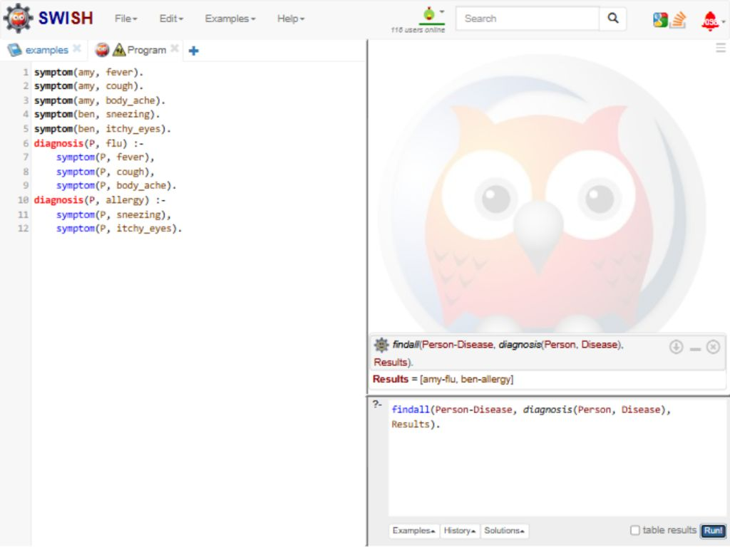
RESULT
Thus, the sample rules matched Amy with flu and Ben with allergy.

